**

**Topic – Grocery Website**

**Group Members :**

**1. Priyanshu Goyal - 12217553**

**2. Ankit Mishra - 12217033**

**Section: KOC21**

**INTRODUCTION**

**The service of online grocery delivery is prevalent in urban areas of North America, Europe, and Asia. A physical supermarket or grocery store that also accepts online orders is referred to as an online grocer. This service typically entails a delivery fee. Mobile apps or e-commerce websites are used for online ordering. Sometimes these e-commerce websites are specifically built for grocery shopping and those websites are called Grocery Websites.**

**Login Page/Create Account Page**

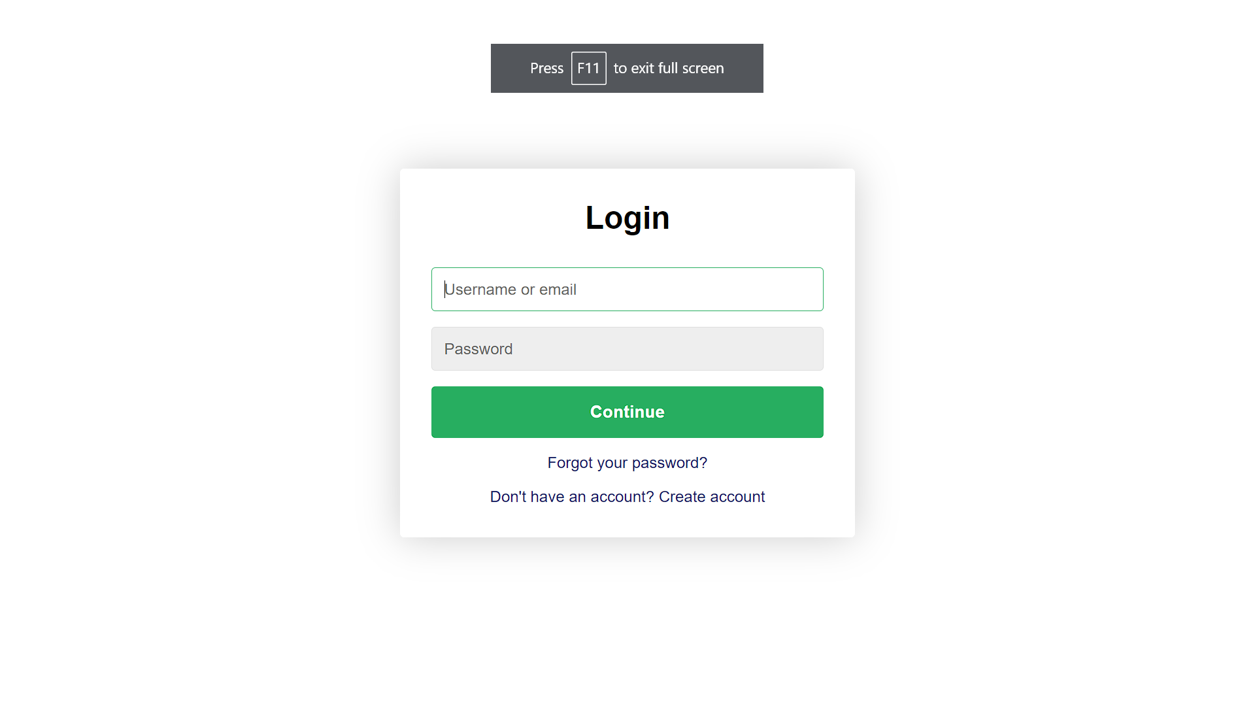

**Home Page of our website**

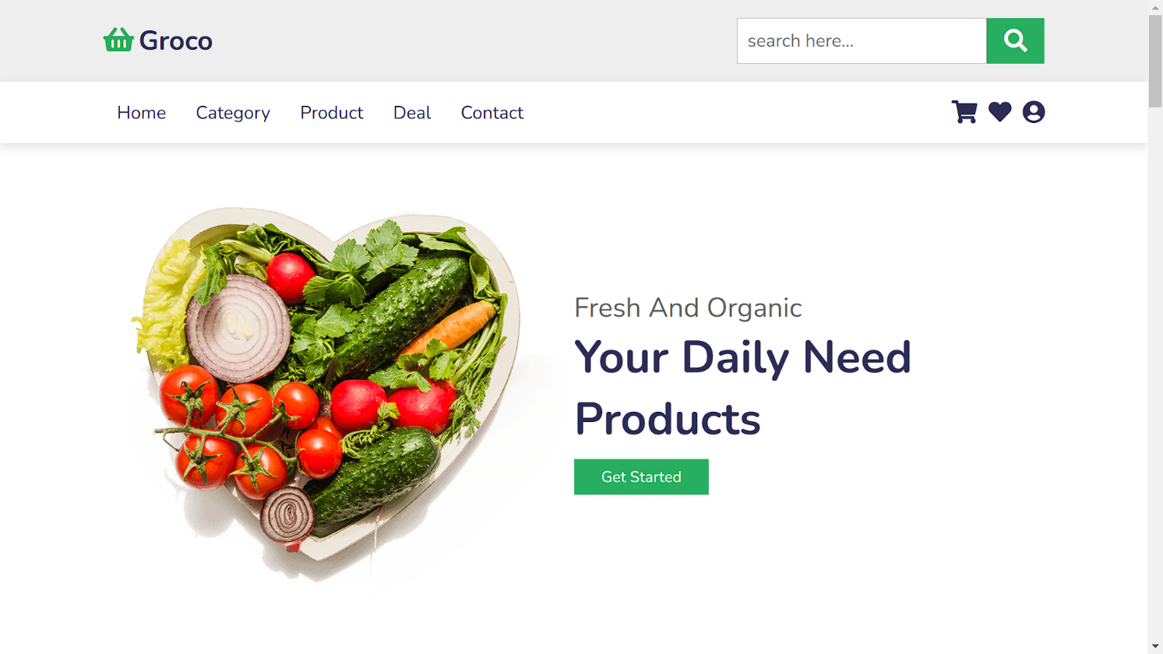

**Products on our Website**

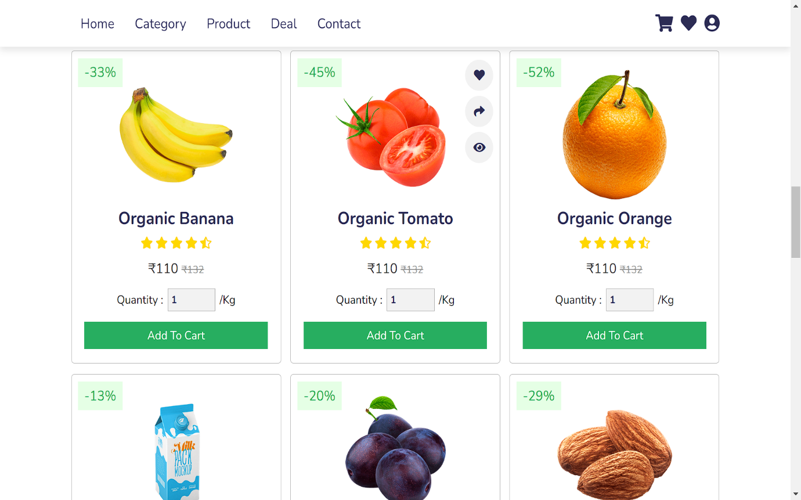

**Timer for Sales alert**

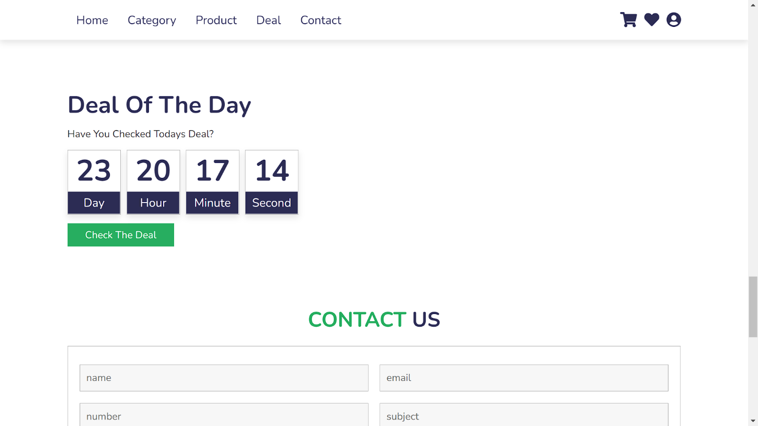

**Screensorts of codes:-**

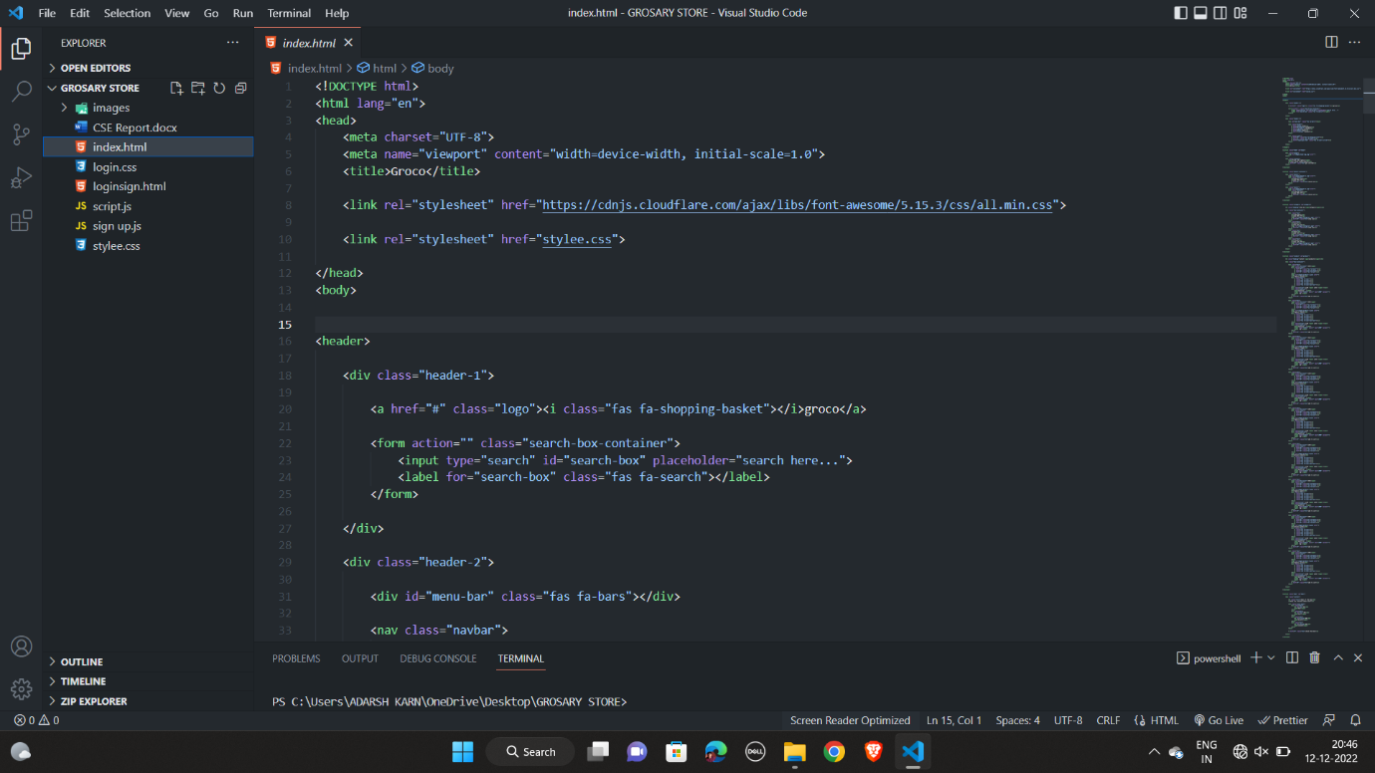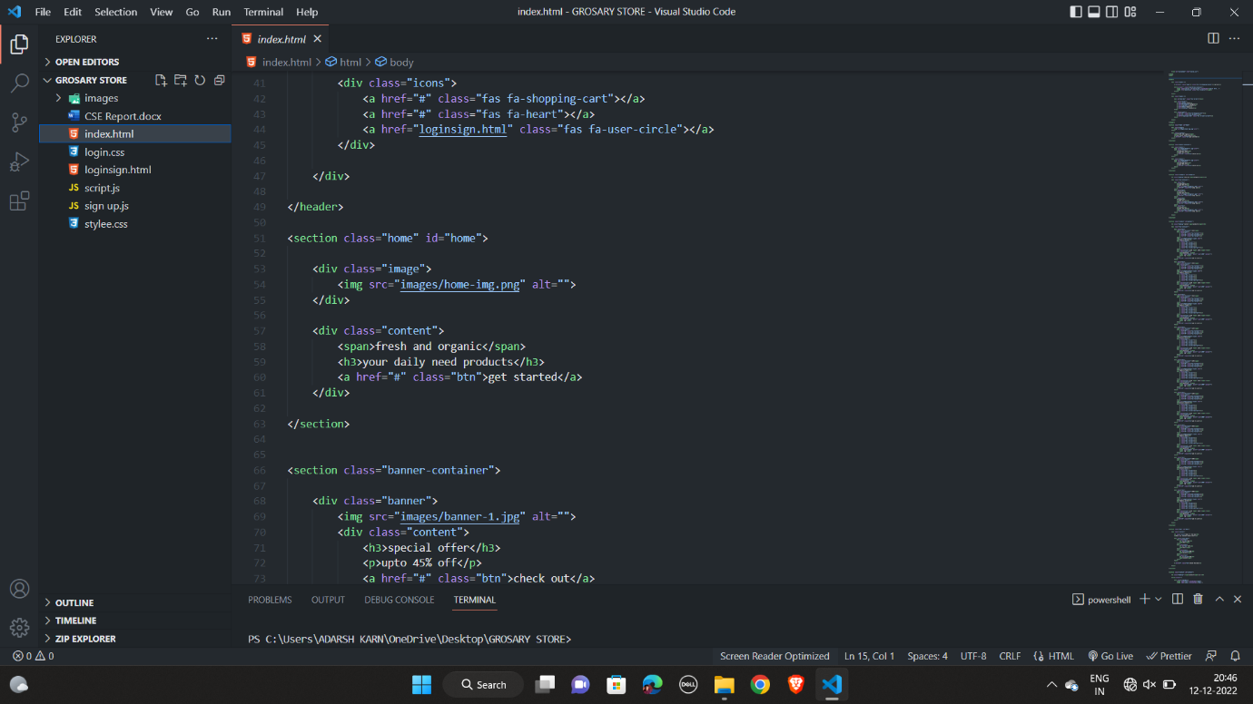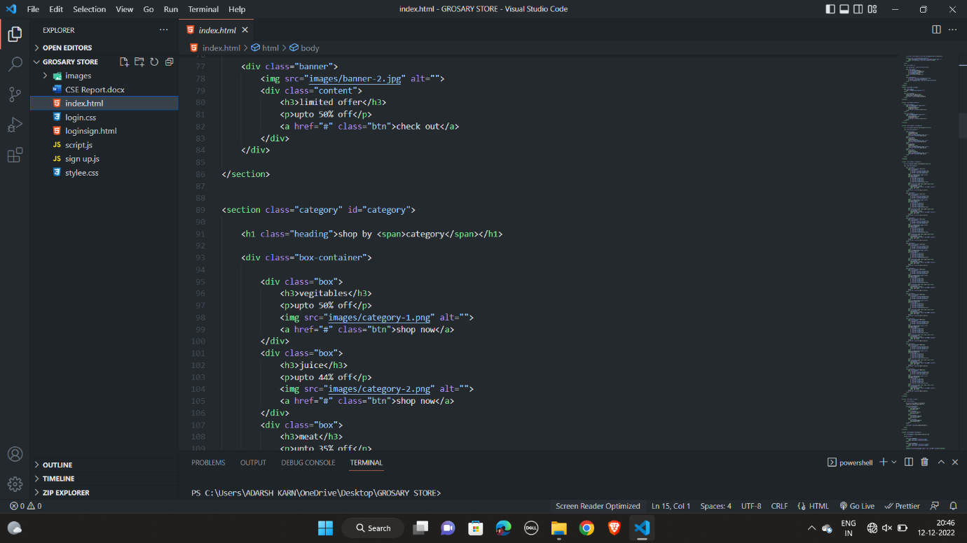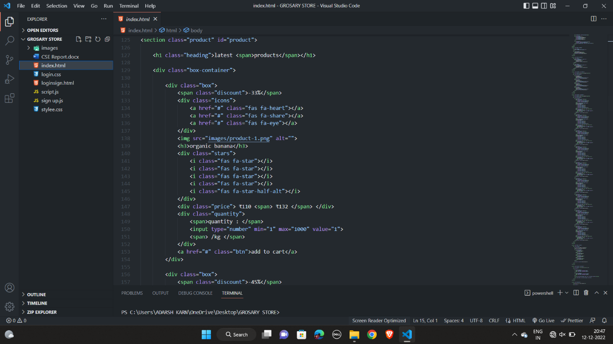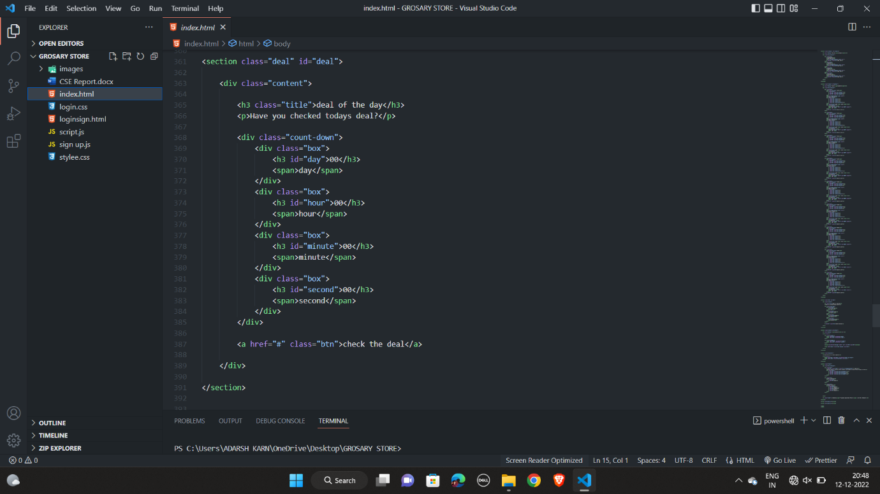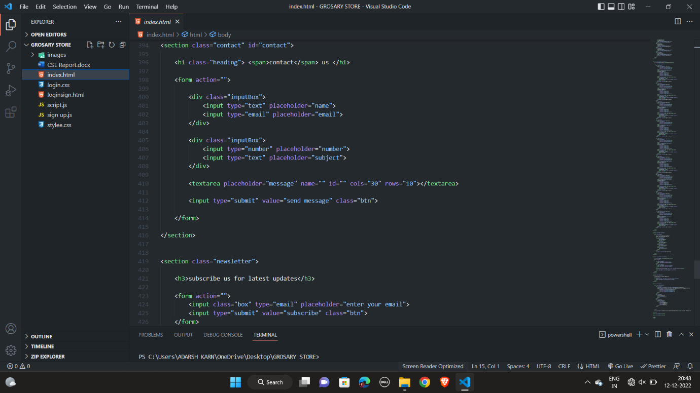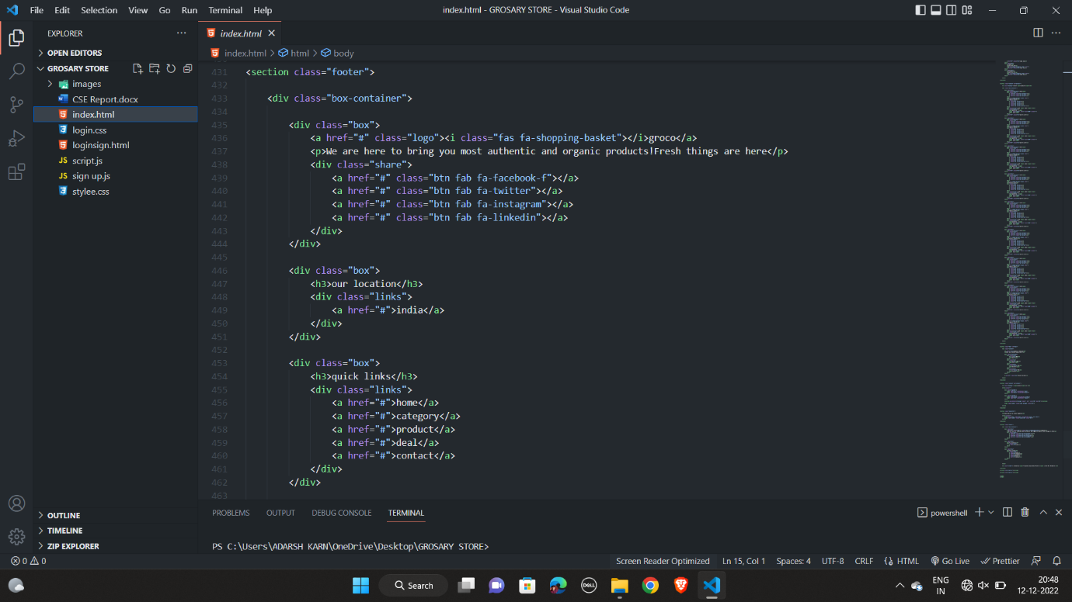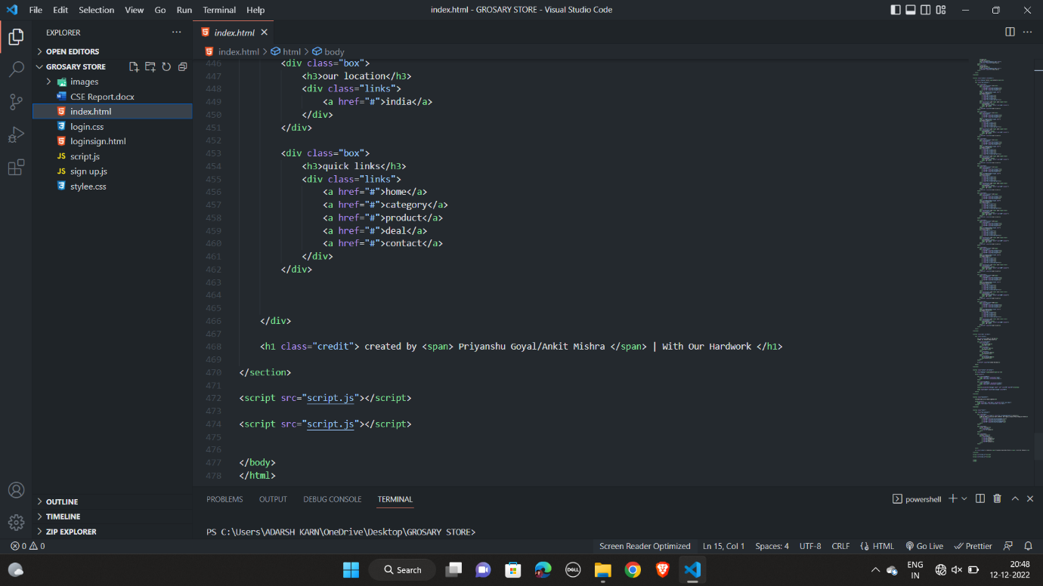

**Technologies We Used**

1. **HTML**
2. **CSS**
3. **JAVASCRIPT**

**•TAGS USED IN HTML:**

* **<div>**
* **<html>**
* **<head>**
* **<body>**
* **<title>**
* **<text area>**
* **<nav>**
* **<img>**
* **<a>**
* **<section>**
* **<p>**
* **<span>**
* **<i>**
* **<h3>**
* **<script>**
* **<meta>**
* **<link>**
* **<h1>**
* **<form>**

**Conclusion**

* **The grocery project, finished website complies with all necessary design requirements. An intuitive user interface is offered by the website. Everything has been tried, and everything works perfectly. As a result, the website has achieved all of its goals.**
* **The user-friendly user interface will save time.**
* **The webpages' real-time results have been distributed. Consequently, the program has demonstrated its effectiveness.**

**References**

* [**https://www.google.com/**](https://www.google.com/)
* [**https://www.w3schools.com/default.asp**](https://www.w3schools.com/default.asp)
* [**https://www.youtube.com/watch?v=dOdF_YlQcms**](https://www.youtube.com/watch?v=dOdF_YlQcms)